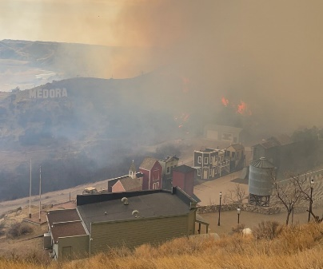
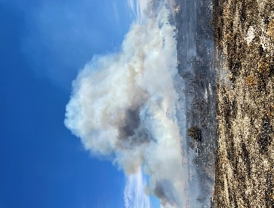
Dakota Prairie Grasslands
Temporary Fire Positions
USDA FOREST SERVICE
NORTHERN ROCKIES REGION,
Dakota Prairie Grasslands
Dickinson, ND and Watford City, ND
The Dakota Prairie Grasslands will be advertising temporary Fire Engine positions for the 2025 fire season. Openings may be available at the GS-03, GS-04, GS-05 grade level positions. These are temporary wildland fire positions with a three-to-six-month tour of duty located in Dickinson and Watford City North Dakota. Our earliest anticipated start date is early to mid-April May 2025, the length of tour is negotiable to accommodate school students. We expect to operate until late September or early October.

Forestry Aid/Forestry Technician (Fire)
Aids and technicians will operate as part of a wildland fire suppression Type 6 engine crew module performing such duties as wildland fire suppression, fuel reduction treatments, prescribed burning, preparedness, fire prevention, and patrol. Other duties may include the maintenance and repair of firefighting tools, equipment, and facilities and firefighter training. The work requires strenuous physical exertion for extended periods of time to include walking, hiking, shoveling, chopping, throwing, lifting, and carrying objects weighing 50 pounds or more. Many of these tasks occur in steep or difficult terrain in all kinds of weather. The work may be hazardous that will require the use of Personal Protective Clothing, which will be provided.
For more information about the positions, please contact Robert Hanley 701-761-9219, robert.hanley@usda.gov or Randy Fischer 406-941-2673, randyfischer@usda.gov
These positions will be advertised under the Nationwide announcements that can be found at www.usajobs.gov
1. ONLY on-line applications are accepted through www.usajobs.gov
2. New applicants must create a new profile within www.usajobs.gov
3. Temporary job Announcements should open October 24th and close November 6th:
- GS-3 Forestry Aid 25-TEMPF3-R1-3867-3DH
- GS-4 Forestry Technician 25-TEMPF3-R1-3868-4DH
- GS- 5 Forestry Technician 25-TEMPF3-R1-1477-5DH
4. Be sure to indicate the correct duty station(s) of the location(s) of where you wish to be considered.
5. If you have previously applied for this position under the old announcement numbers, you will need to re-apply with the new announcement numbers.
6. We anticipate requesting the applicant lists as early as December 2024.
***Housing MAY be available at both duty stations
If you are having difficulty applying for the position through the USAJOBS, you may also contact: HRM_Contact_Center@usda.gov or Albuquerque Service Center at 877-372-7248

