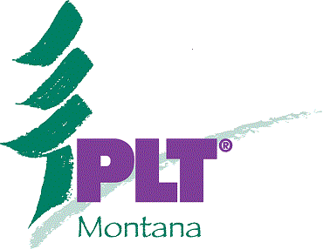

Project Learning Tree
“Teaching Kids How to Think…Not What to Think”

“Getting Kids Outdoors in Montana”
“Workshop Theme: What’s Bugging Our Trees?”

Agenda for Thursday, October 21st Workshop at West Glacier Elementary School
(Earn Credits in the Flathead for PIR Days)

9:00 Presenter introductions and opening remarks. “What do you want to get out of this workshop?”
(Frances and Holly….Also, West Glacier Elementary School Principal and teacher, Cortni King to tell us a few of the unique opportunities her students have for an “outdoor connection”)
9:15 Icebreaker Activity #54, Pg. 236. “I’d Like to Visit a Place Where…..” Part B, #4 questions. (Frances)
9:30 Introduction to PLT and Background Information (Holly)
(What is PLT, its function, who are its sponsors?)
9:45 Inquiry-Based Teaching and Learning. Activity #27, Pg. 117 “Every Tree for Itself”
(Holly and Frances)
10:30 Break

10:45 Hike the PLT guide: how to find valuable information in your new guidebook! (Holly)
Explain “Each One Teach One & Poster sign-up for afternoon program” (Frances)
11:30 Working lunch (out on the School Hiking trail –weather permitting).
Guest Speaker to join us for lunch walk. DNRC Service Foresters, Rick Moore and Dave Jones, will offer a short course on 2 active forest pests that are currently wreaking havoc on several species of trees in Montana: Mountain pine beetle and spruce budworm. Attendees will learn the lifecycle of these critters and how they spread. Also, the size and scope of this current epidemic and what Montanans might expect to see in the future.
1:00 Activity #84 Pg. 363. “The Global Climate.” Mauna Loa Volcano exercise. (Frances and Holly)

1:30 Each one teach one. Small groups teach an activity to the rest of the group. 15 minutes prep time, 15 minutes teaching time for each group (2-4 people per group). Frances Erler will demonstrate the 1st example with a partner from the workshop: “It’s autumn” emphasis on music as an aid for teaching.

Choices for activities from the Pre-K – 8th grade guide:
Diversity Theme:
#13, pg 65, We All Need Trees, part B: Mystery Products
#10, pg. 50, Charting Diversity
Interrelationships Theme:
#25, pg. 111, Birds and Worms
#26, pg. 113, Dynamic Duos
#12 pg. 59, Invasive Species
Systems Theme:
# 45, pg 194, Web of Life
#56, pg. 241, We Can Work It Out
Structure and Scale Theme:
#63, pg 269, Tree Factory
#76, pg 327, Tree Cookie
#69, pg. 291, Forest for the Trees
#74, pg. 318, Tipi Talk
Patterns of Change Theme:
#82, pg. 355, Resource-Go-Round, part A
#84 pg 363, The Global Climate
#35 pg. 147, Loving It Too Much!

3:00 Additional PLT Resources, website.
Earth & Sky Link – PLT Activity Pages (see Student Pages).
PLT Correlations to MT Content Standards: http:/www.msuextension.org/plt/ (Holly)

3:20 Group Discussion:
- How can PLT, Service Learning, and Inquiry –Based education be put to use in your educational setting?
- Share stories from personal experiences and ideas.
- Network and share personal contact information.
- Fill out evaluations for the workshop please!
3:30 Adjourn and drive home safe!

Every Student Learns Outside! “Where the Natural World Becomes Your Classroom.”

Instructor Contact Info:

Project Learning Tree Coordinator: Workshop Facilitator:
Cindy Bertek, Forest Stewardship Coordinator, Frances Erler, Teacher and PLT Facilitator
MSU Extension Forestry Whitefish, Montana
(406) 243-4706 mferler@gmail.com
Cindy.peterson@umntana.edu

Workshop Coordinator:
Holly McKenzie, Local Consulting Forester.
1370 4th Ave W.N. Columbia Falls, 59912
(406) 892-4141
hmckenzie@centurytel.net

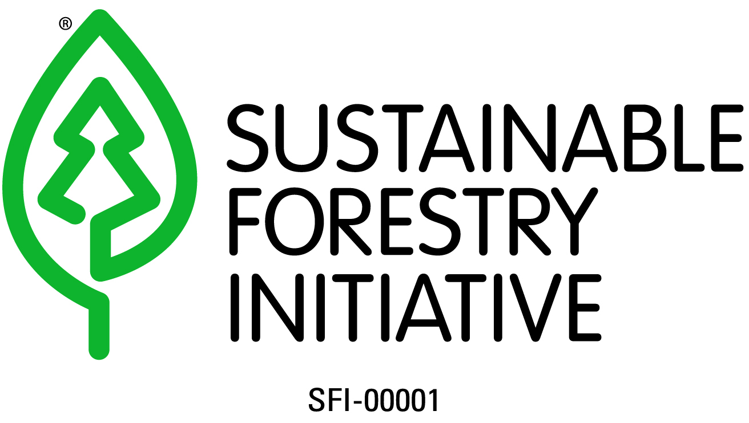

Project Learning Tree is the environmental education program of the American Forest Foundation and is sponsored in Montana by MSU Extension Forestry, in part funded by the MT DNRC and USFS.

The Montana State University Extension Service is an ADA/EO/AA/Veteran’s Preference Employer and Provider of Educational Outreach.

